Descarga APP sistema Android :
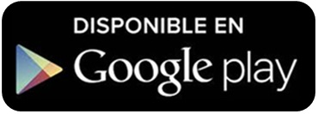
https://play.google.com/store/apps/details?id=com.clapp.podocat

Descarga APP sistema Apple :
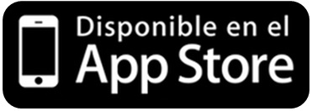
https://itunes.apple.com/es/app/podocat/id983268841?mt=8

